1. Create ZAGI database
   1. Refer to ER-diagram, relational schema, and table definitions on p. 142-143 in the textbook.
   2. Use the database that has been created for your username (i.e., DSCI_723_U820T_YOURNAME)
   3. Watch the following videos:
      1. DSCI 723: How to Create a Database Diagram
      2. DSCI 723: How to Create Tables
   4. Create the “zagi” schema first and put all the tables under that schema in your database. Further details on creating a schema:
      1. <https://docs.microsoft.com/en-us/sql/relational-databases/security/authentication-access/create-a-database-schema?view=sql-server-ver15>
      2. <https://docs.microsoft.com/en-us/sql/t-sql/statements/create-schema-transact-sql?view=sql-server-ver15>
   5. Create a database diagram. Note that you may already have one, if that is how you created your database. Alternatively, you can create a diagram from existing tables as well.
2. Populate the ZAGI tables with data. INSERT statements are included with this assignment in a separate text file (zagi_insert_statements.txt)
3. Submit your database diagram in D2L
   1. While it may be tricky to get it to fit on one page, there is a convenient way of putting the image of the diagram in a file.

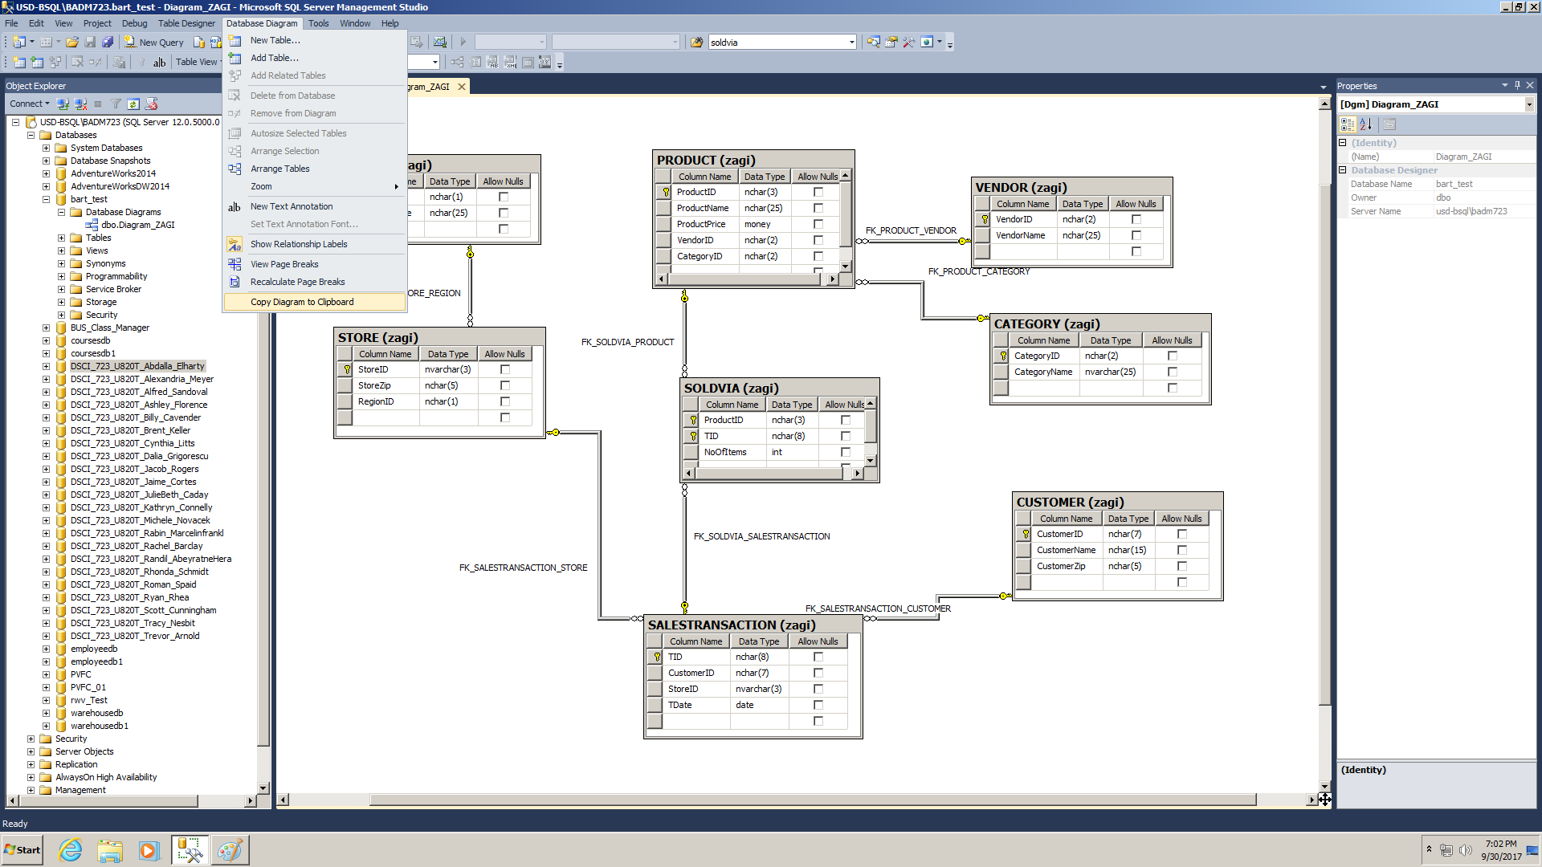

* 1. With the diagram open, point to **Database Diagram** and select **Copy Diagram to Clipboard**.
  2. Open **Paint**, **Paste** the diagram in, and **Save** it as an image. You can either submit the image, or paste the image to a Word file and submit the document with the image pasted.